3-D HORN

SHUBHAM JAISWAL (Author)
SHRUTIKA UPASE (Co- Author)

Abstract— 3-D horn is a vehicle to vehicle communication based technology which helps in reducing the noise pollution, which occurs, due to honking of automobile horns by letting only the drivers of the automobile to hear the horns and not the whole environment around him. To achieve this, a number of relatively small horn speakers are placed inside the car. These speakers are controlled by drivers of other cars. In this way honking will be heard only by the drivers. The most unique feature of this technology is the 3-D effect caused by the speakers which will let the driver know the location of the outside car which is honking. The 3-D effect is achieved by varying the intensity and proper allotment of sound to the positioned speakers in such a way that it will give the feel of the location of the outside car to the driver. Human detection is another important feature this technology provides. It will recognize whether the horn is honked for an automobile or for a human. In case of human an external horn will be honked otherwise 3-D horn will be honked. A combination of GPS and RADAR is used to achieve this functionality.

Index Terms— GPS, RADAR, XIGBEE, 3-D HORN, V2V COMMUNICATION.

Introduction
Noise pollution is a serious threat to this world. Automobile companies make horns because it’s required, but its usage totally depends on the driver of the automobile. Honking of the cars has a significant contribution in the world’s total noise pollution. There is an urgent need to tackle this situation in today’s scenario. Few years down the line, the number of automobiles running on the road will be increasing exponentially and also the honking of the cars.
To tackle this situation, 3-D HORN is one of the most effective technology one can use. The concept of 3-D horn is entirely opposite to that of normal horns currently in use. Instead of placing the horn’s speaker outside the automobile, we are placing an array of relatively small horn’s speaker inside the car. These arrays of speakers will be honked by the surrounding cars. This means that outside cars (installed with this technology) will be able to control the horn’s speaker inside our car. In this way, the surrounding environment will not be effected by the sound of big horns normally placed outside a car. Here, only the driver of our car will be able to listen to the horn and nobody else, thus solving our purpose. Not only this, but our driver will also be able to sense the location of the surrounding car because of the 3-D effect of the arrangement of speakers inside the car.

The 3-D EFFECT
The 3-D effect of this technology is what makes it different and unique from other technology solving the same problem. Due to this 3-D effect, the driver will not know that he is sitting in a car installed with this technology. The 3-D surround sound produced by the array of speakers will make it so natural that the driver will feel as if some outside car is honking. To make this possible we need a mechanism which can find the location of the outside car. Location will be including 2 parameters viz. distance and angle. To give the feel of the distance of the outside car, we are varying the intensity of the sound emitted by the speakers, and for the angle of the car, sound will be allotted to different positioned speakers in such a manner that it will give the feel of the distance and angle of the outside car with respect to our car. We need a minimum of 12 small speakers (3 on each side) inside the car to accomplish our task. The allotment of sound to the speakers is in such a way that it will give the feel of the direction of the outside car which is honking. Following diagram (Figure 1) will show an example of such a scenario. As shown below, there are 9 cars moving in the same direction. The car marked green is OUR CAR and other cars are termed as SURROUNDING CAR. In the case shown, OUR CAR will act as master and SORROUNDING CAR will act as slave. Position of horn’s speaker is also shown by red dots. Each car is having 12 horn’s speaker distributed uniformly inside the car. The horn marked green is the active horn, which means, these are the horns currently honking inside their respective car. Consider an example of car 2. OUR CAR is just behind car 2, therefore the allotment of sound goes to the three horn speakers situated at the back of car 2. Same goes with all the other cars shown in the diagram.
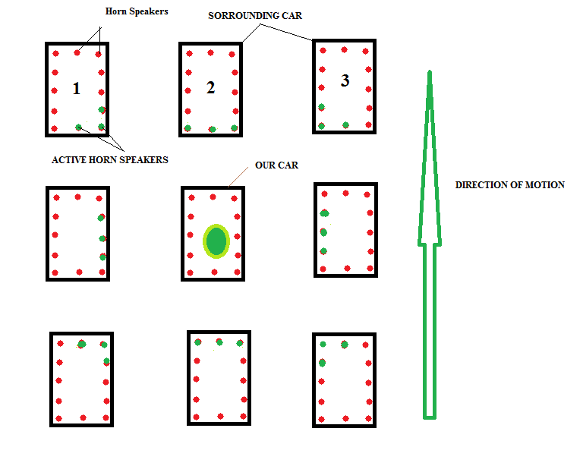
FIGURE 1

In this way 3-D effect is achieved without being known by the driver and the sound will be heard by the drivers only, thus reducing the noise pollution to a very low level.

Sequence of flow
Starting from t=0 when a car driver presses its horn button to t=t when 3-D horns are activated, given below is a flowchart showing the sequence of the whole process which takes place between two cars named as OUR CAR and CAR 2.
As shown in the diagram (Figure 4), car 2(which is here acting as slave) is continuously waiting for the signal for horn activation. When OUR CAR driver presses the horn button, then signal is sent to its GPS to read the coordinates to 5 decimal places to ensure a resolution of 1.1 meters in the coordinates. As soon as coordinates are received, a signal consisting of start of frame, message frame and end of frame is sent via XIGBEE transmitter. Message frame will consist of “horn request data bits” + “GPS coordinates data bits”.

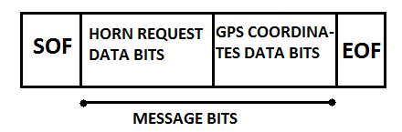

FIGURE 2: HORN REQUEST FRAME

XIGBEE signal is sent to a radius of 100 meters which is the expected range of a XIGBEE transmitter. This signal will be received by every vehicle in its radius.
CAR 2 receives the signal and extracts the GPS coordinates from the message frame bits. Now the corresponding intensity of sound will be allotted to the array of speakers according to the coordinates received and the process is completed.
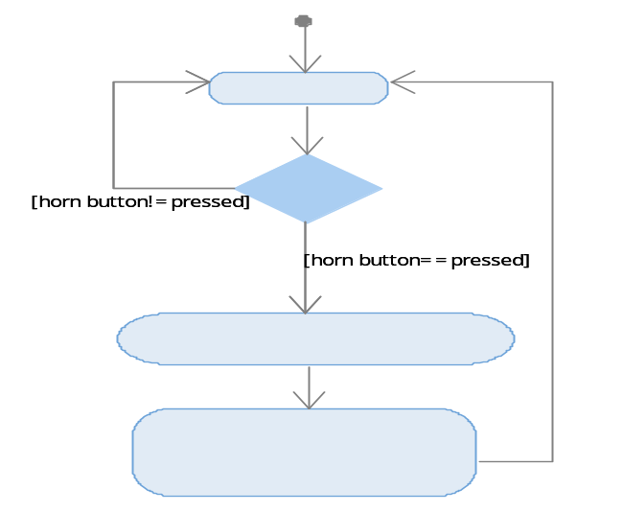

FIGURE 3: OUR CAR FLOWCHART

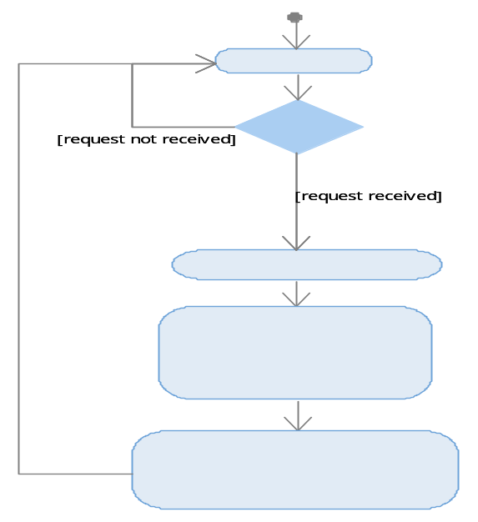

FIGURE 4: CAR 2 FLOWCHART

INTENSITY AND ALLOTMENT OF SOUND
The 3-D effect works because of the intensity variation and allotment of sound to the corresponding speakers. The ECU has to decide the intensity and the allotment of sound from the GPS coordinates value received. Following block diagram shows the circuit connection of different components used to achieve this 3-D effect.
The green color block is a relay which is activated by the ECU when a particular speaker is to be allotted the sound of horn.
The blue color block is the volume controller or an audio amplifier which is responsible for varying the intensity/volume of the sound so that the driver is able to visualize the distance of the outside car through the sound produced by the speakers.
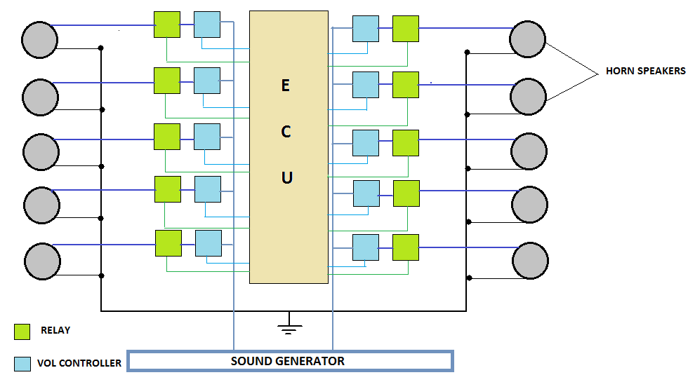

FIGURE 5: BLOCK DIAGRAM

Sound generator is a device which keeps generating a particular sound frequency signal which is the sound of the horn. It is predefined and cannot be changed.
Thus when GPS coordinates are received, the ECU activates the relay and set the volume controller depending upon the coordinates received so that the 3-D effect can be achieved.

HUMAN DETECTION
Use of horns in day to day life is not only for other vehicles but is also for pedestrians which may include humans and animals. In case of humans/animals, this technology will not be helpful. We will need an external horn which will be honked by ECU only when a human /animal is in front of the car. Therefore there is a need to recognize whether the driver is honking for a car or for a human. It typically looks like reading the mind of the driver to find out the reason as to for whom the driver has honked the horn.
This requirement is achieved by the use of combination of RADAR and GPS. Following flowchart shows the sequence of action to be taken to achieve our requirement.

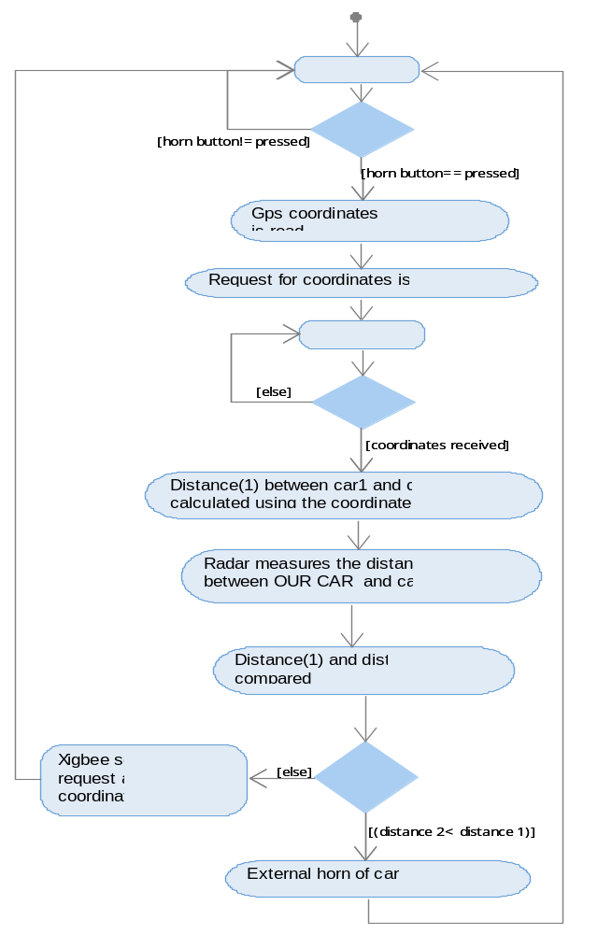

FIGURE 6: HUMAN DETECTION FLOWCHART FOR OUR CAR
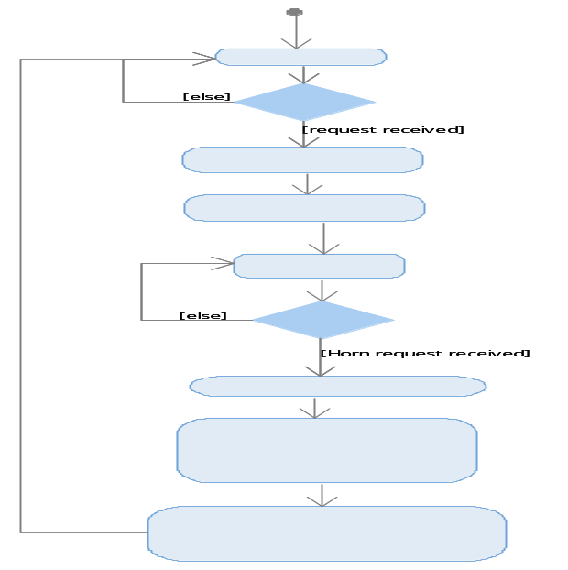

FIGURE 7: HUMAN DETECTION FLOWCHART FOR CAR 2

To detect the presence of human, two types of distance are compared with each other. Distance(1) is calculated by subtracting the coordinates of two cars and Distance(2) is measured with the use of radar. As soon as horn button is pressed, request for coordinates are sent to car 2. When the coordinates are received, it is subtracted from OUR CAR coordinates to find the distance between the two cars. This distance is called Distance(1). Distance(2) is measured using a radar. If there are no humans in front of the car, then both the distance will be equal. If there is any human, then Distance(2) will be less than Distance(1), as Distance(2) is measured using radar. By this method we are able to distinguish between a car and a human. Depending upon which distance is less, corresponding actions are taken. If Distance(2) is less, that means a human is in front of the car. In this case external horn will be activated by the ECU. Otherwise, signal for 3-D horn will be sent. Below diagram shows how these two types of distance are measured in presence and absence of human/animal. When there is no human then Distance1=Distance2 otherwise Distance2<Distance1.
Note: Distance1 is measured using coordinates provided by GPS and Distance2 is measured using RADAR.

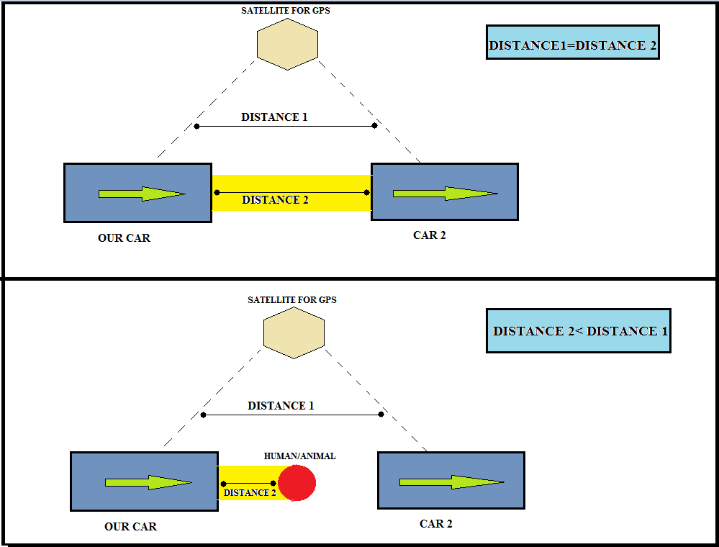

FIGURE 8: HUMAN DETECTION DIAGRAM

CONCLUSION
Internal 3-D horn based on V2V communication is a technology which will revolutionize the way automobile industries use horns. It solves the purpose of honking without disturbing the environment. It will bring a huge reduction in the noise pollution as compared with the current scenario. The 3-D effect is the most astonishing feature this technology provides which will make the whole process so natural that the driver of the car will feel as if some outside car is honking the horn even though the horns are inside the car. Also his brain will be able to locate the position of the car because of the 3-D effect. This technology also provides a solution to find out whether the horn is honked for an automobile or a pedestrian. It uses a combination of RADAR and GPS to differentiate between the two entities. If a pedestrian is detected then an external horn will be honked otherwise internal 3-D horn will be activated. Thus this technology provides a unique solution to the problem of noise pollution and is able to solve it in a safe, reliable and effective way.

Patent References:

Publication number: US8307037 B2
Application number: US 11/265,091

Publication number: US6765495 B1
Application number: US 09/589,637

Publication number: US7499675 B2
Application number: US 11/593,567

Publication number: US20060161315 A1
Application number: US 11/283,913

